**Azure DevOps:** Service offered by azureIn simple, Placing all the devops tools and using azure infrastructure to run devops pipeline!  
Devops is automation and doing automation in azure environment is Azure devops  
  
**Azure devops consists of a set of services which provides tools for implementing and achieving devops lifecycle!**  
  
Redhat:  
It offers multiple open sources like servers, licenses, security , different types of operating systems ,containerization!  
  
When this company wanted to launch any new product at that time they need to have **plan** initially, later developers will be workingcode and then testing people will be doing testing and later all done we will go for deployment!  
  
for above things different tools should be used and different persons involved should be categorized into different teams, You should be able to manage all those!  
  
🡪Here comes in difficult, 1 person cant manage all these , even if it is multiple people then might be some errors, we need a system which doesn’t do any mistakes, kind of dashboards which shows all details of different teams  
🡪We focus more on managing these rather than on product development, so in order to manage the infrastructure cloud computing came in  
  
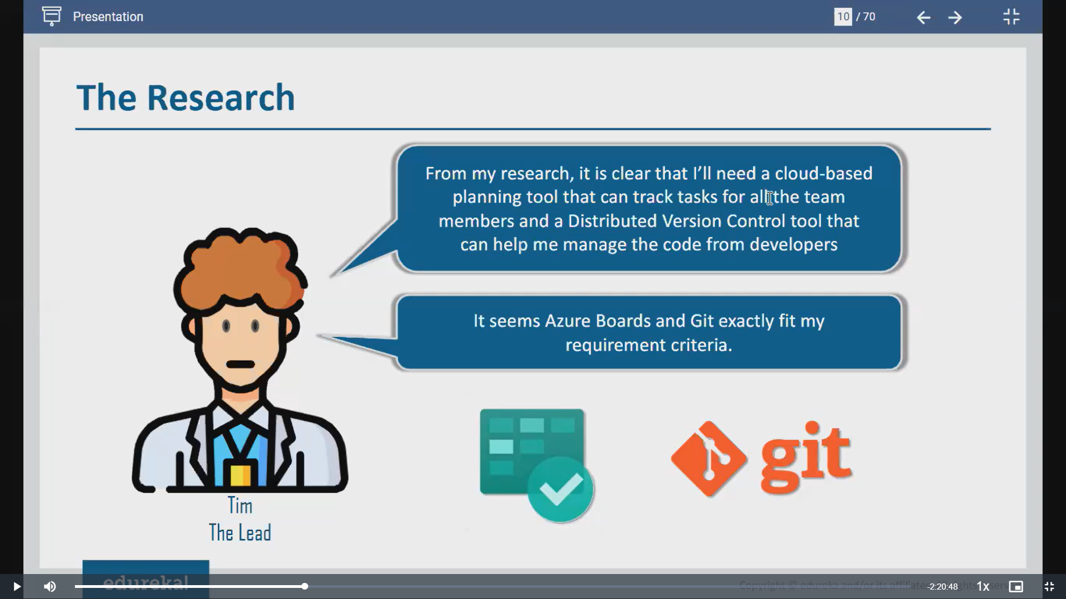  
  
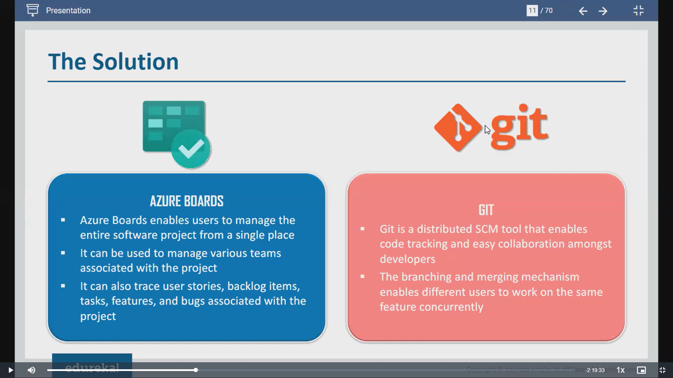  
  
**Cloud Computing:**  
  
It’s a framework or method which alloys its customers to use services which they need via cloud to deploy those apps!  
  
It provides reliability or trust to customers with its services.  
It follows pay as you go model, no limit so you no need to worry about spending money on data centres.   
  
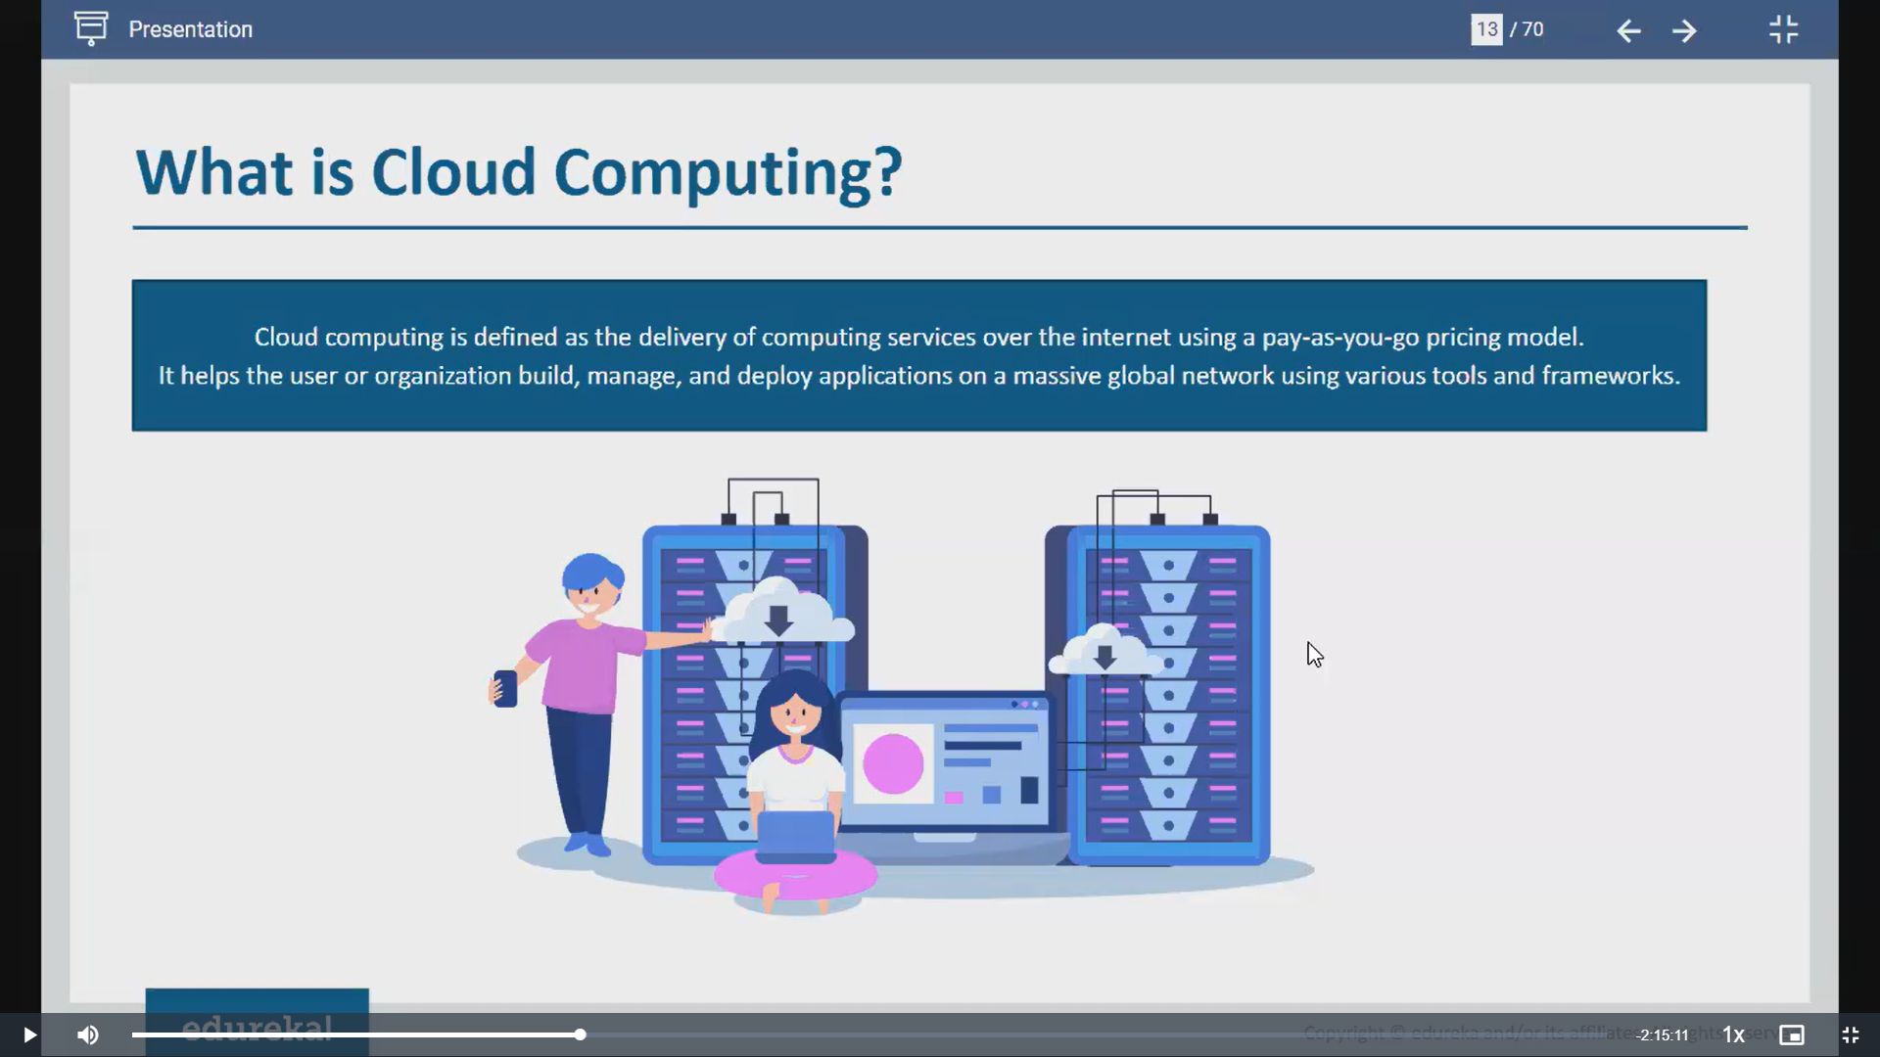

**Azure**:  
  
It’s a Microsoft cloud computing platform, It provides all the services which meets organization’s needs and challenges like apps management, deployment   
  
This azure provide 3kinds of services  
  
1. Infrastructure as a service   
2. platform as a service  
3.software as a service  
  
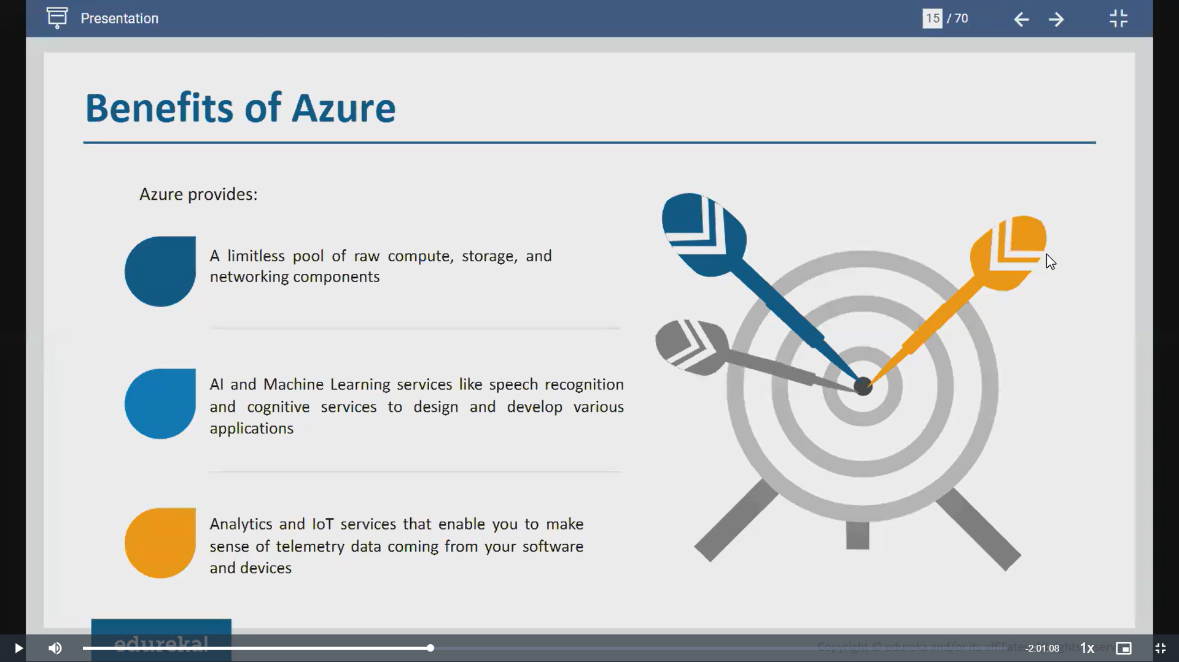  
  
We would be saving important data in vms or our devices , then if vm is crashed or device is stolen then data will be gone, to avoid this we have **persistent storage(**disk outside vm**) ,** this is offered by azure as part of storage!  
  
AI and ML- we have bixbi, siri as speech recognition and drone services as sensors, lights on and off-sensors  
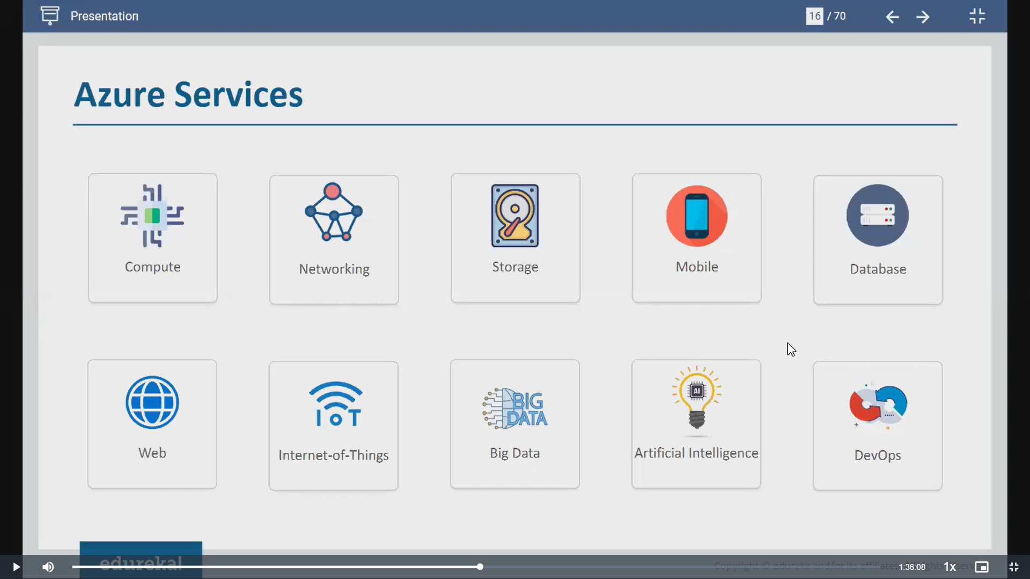  
  
**Compute**: Azure offers a lot of VMs, linux and windows operating systems and containerization service as well  
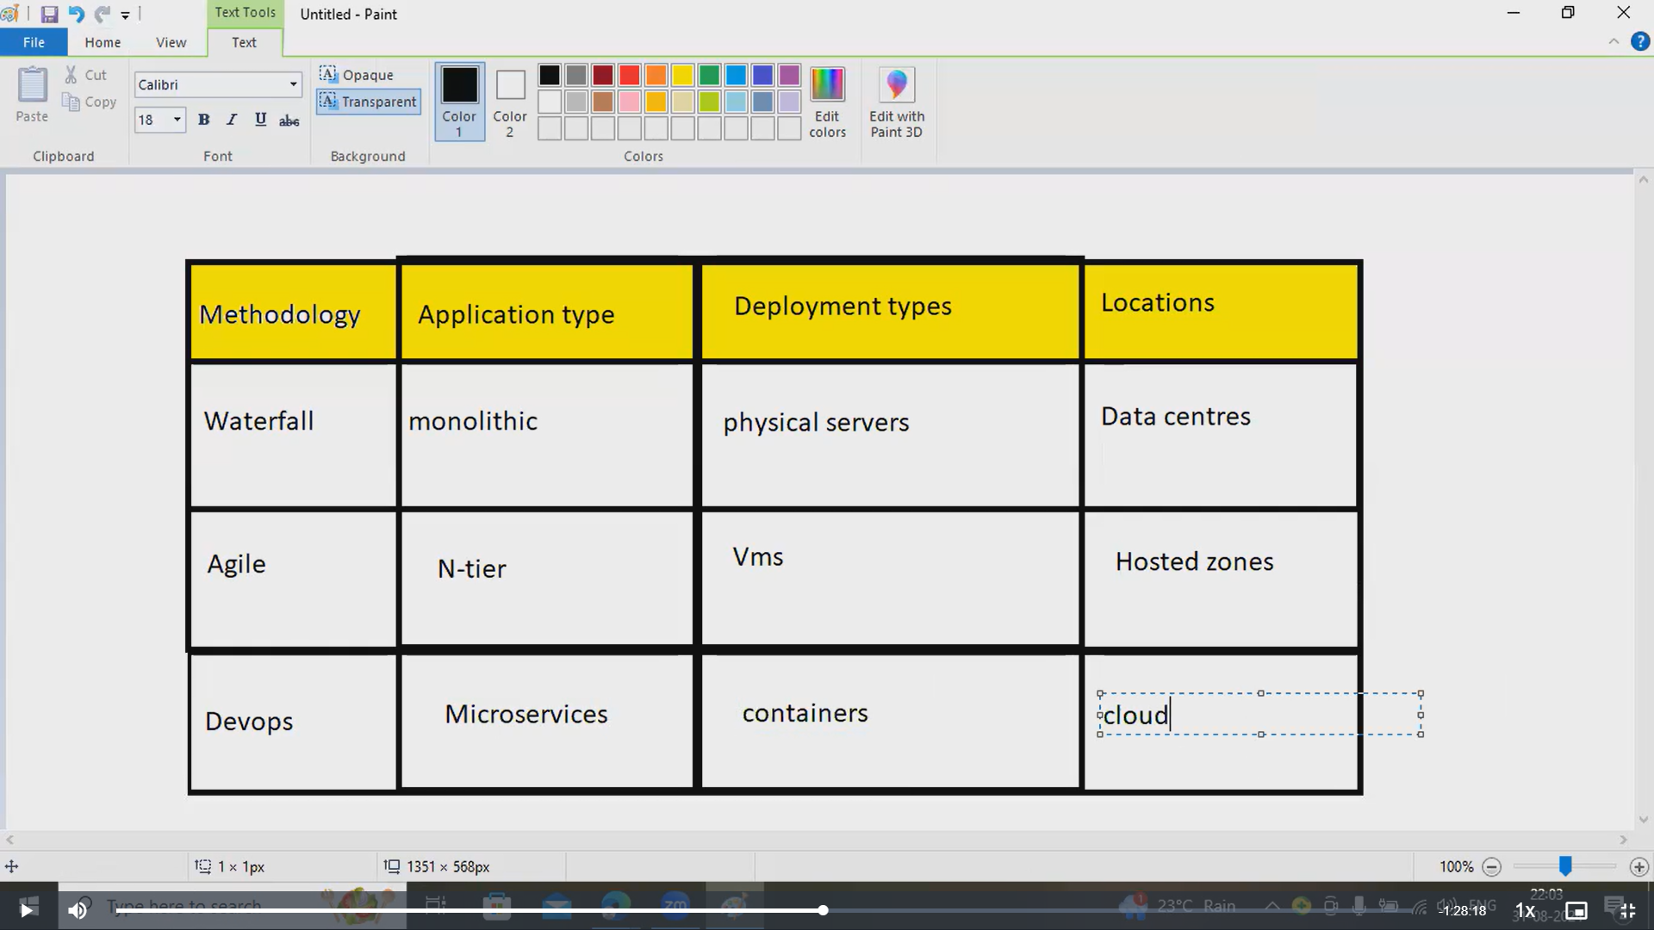  
   
In waterfall, everything is deployed in physical servers , it follows specific process so 1 step is gone everything is gone! Mostly companies used data centres  
  
In agile, we have n-tier, in any app there will be different phases and components, front end which we see, intermediate stage and backend which contains code, different phases are stored in different VMs , whenever you want you can deploy it onto VMs!, work is divided in several iterations  
  
In devops , we have microservices and deployment stage would be in containers and they are already stored in cloud  
  
**Networking**:To reach your app to customers you need wifi or router, azure offers different networks like virtual networking ,ip address, sub networking!  
  
**DevOps**:

DevOps is a set of practices and tools designed to improve the collaboration between software development (Dev) and IT operations (Ops) teams. Its goal is to speed up the development, deployment, and maintenance of software by automating processes and fostering better communication.

In simpler terms, DevOps is about making the whole process of creating and delivering software faster and more efficient by working together and using the right tools.

We have waterfall, agile before devops!  
In waterfall, we cant go back once any stage is fulfilled, it will take a lot of time to complete 1 stage-**Time management is difficult**  
  
Later Agile came in -It works like it breaks entire requirement into iterations. It won’t deploy until requirement is perfectly fulfilled!

If you download any file it will be in .var,.jar etc format, you don’t need to have back code, via build we will pack into packages and deploy whenever its needed!  
This is the stage in devops life cycle which manages the source code.Once all the testing and code is ready then product will be released!  
  
**Azure devops**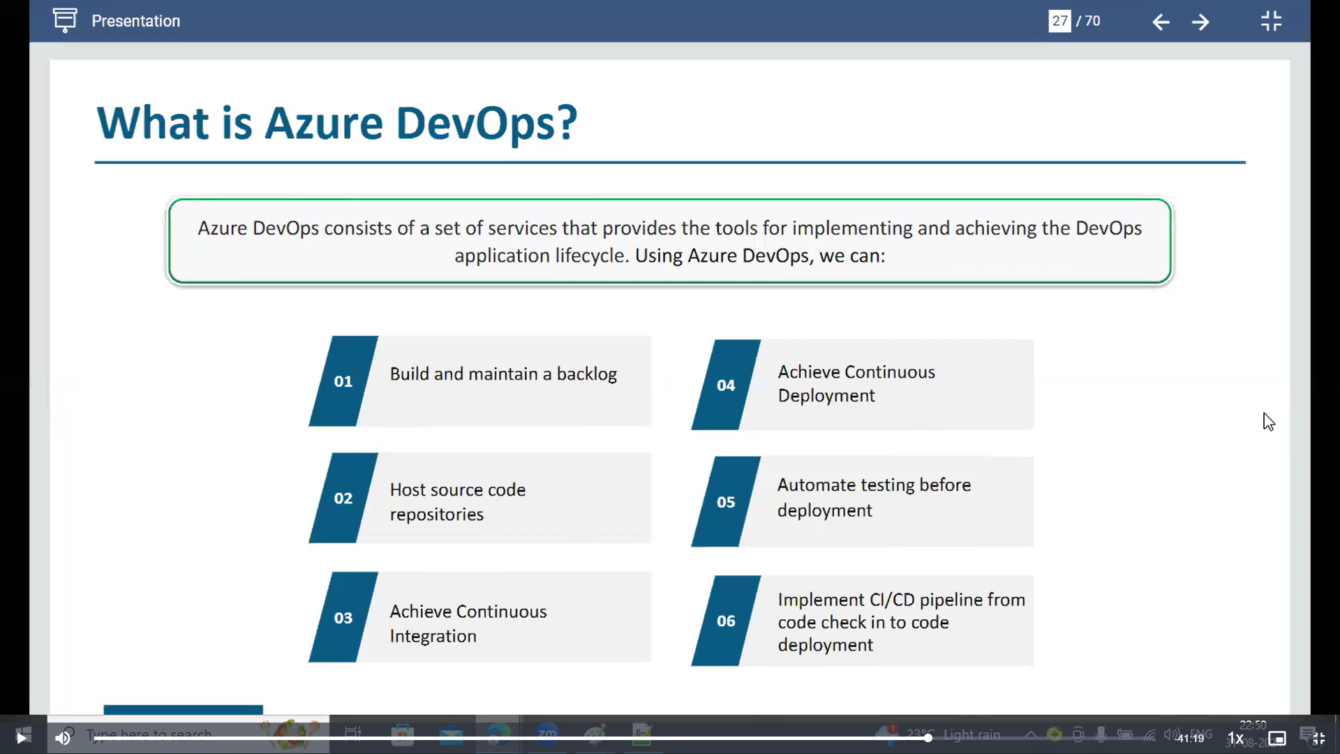  
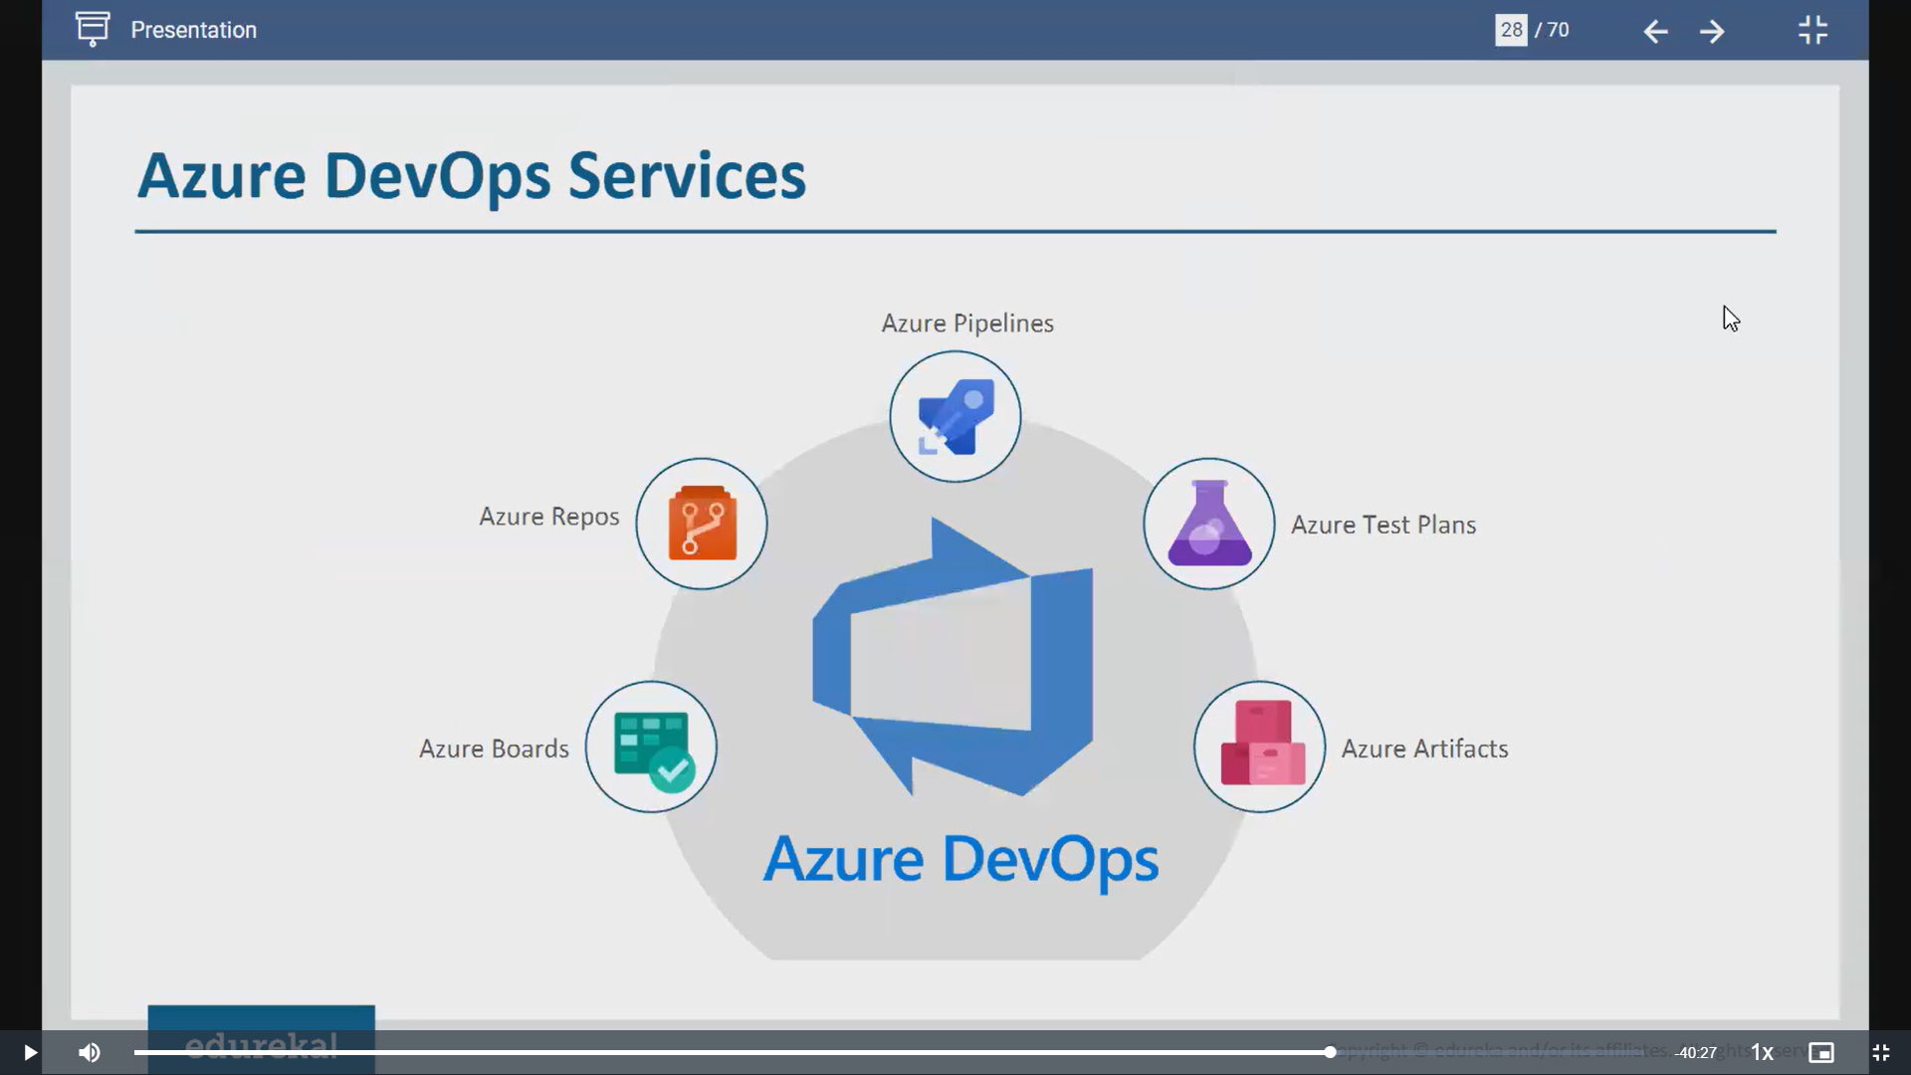  
After creation of azure account, search for azure devops organization -it provides services which azure offers using which you can create devops frameworks  
  
🡪summary contains the work which is done and which is created  
🡪Dashboard contains pipelines overview, how many pipelines running, how many instances created, how many stages running, timelines etc  
  
🡪**Artifact**: outcome of a project act as input of another project  
  
->Azure devops follows both agile and devops approaches i.e., it will follow iterations, sprints and continuous development and integration

🡪Azure pipeline consists of 2 pipelines  
 1. Build pipeline, 2. release pipeline

1st is must for most of the companies

In **build pipeline** we can simply pull the code from repo and build and test it across various environments or created artifacts can be transferred from 1 environment to another environment so u can do testing across various stages across deployment!  
  
You can create artifact and can be tested in multiple stages via build pipeline  
  
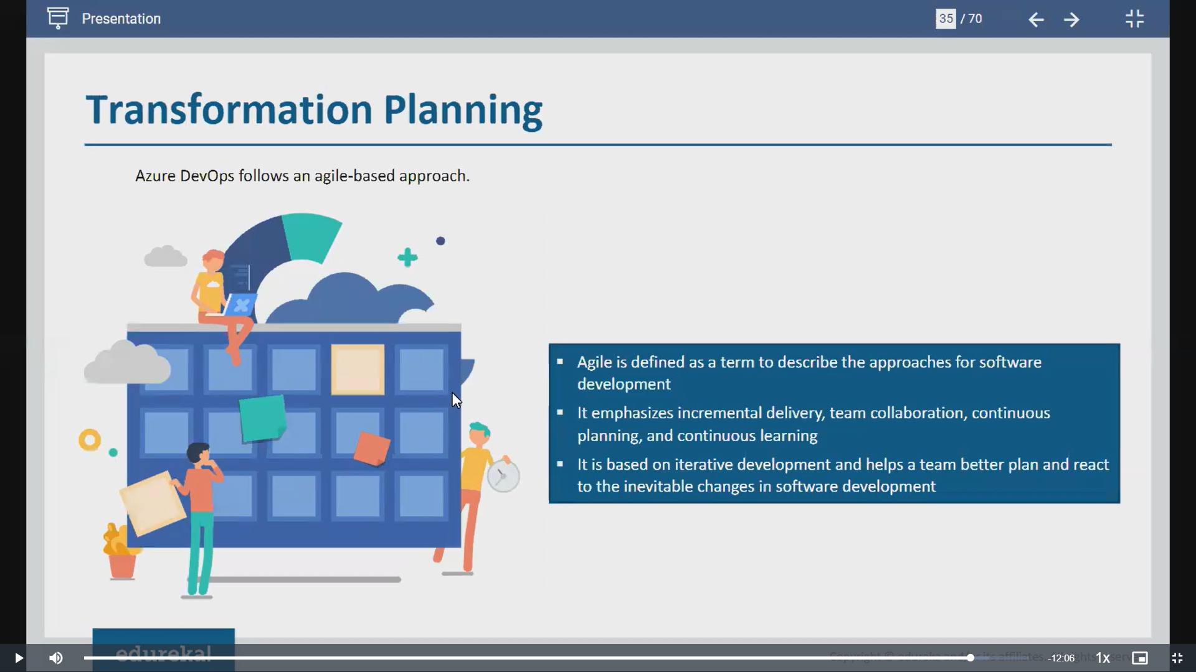  
  
  
**🡪 Scrum** means you use Azure Boards to manage your work in small, manageable chunks called **sprints** (which are usually 2-4 weeks long).

•you create and prioritize a list of tasks (called the **product backlog**).

• At the start of each sprint, you pick some tasks from this list to work on (this is called the **sprint backlog**).

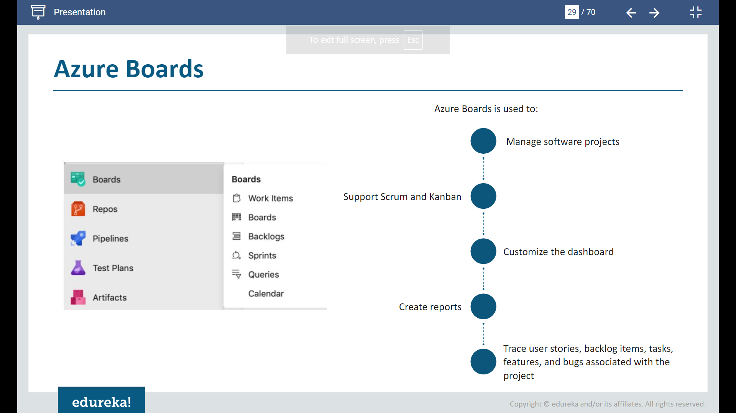  
 **Azure repos:** It’s a tool for managing your code, tracking changes and collaborating within your team!  
 It is same like git, which stores code, version control it-whenever you want to go back to previous code it allows you, improves communication between developers  
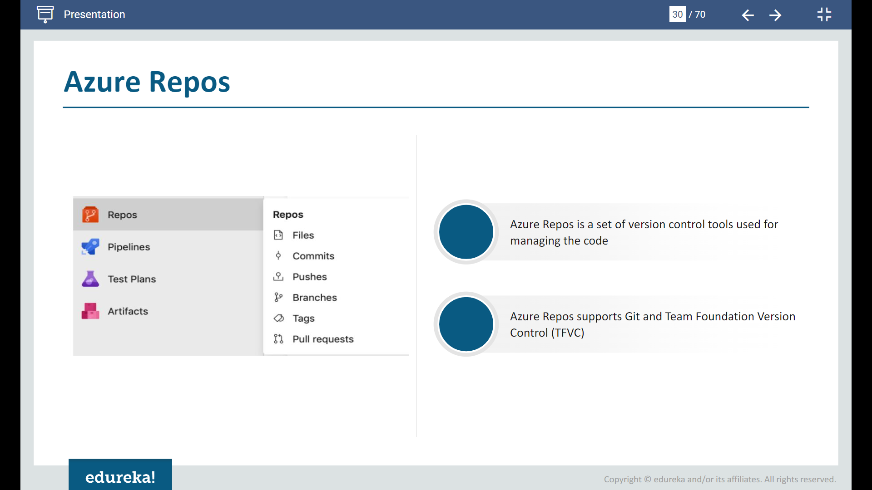  
Azure pipelines: 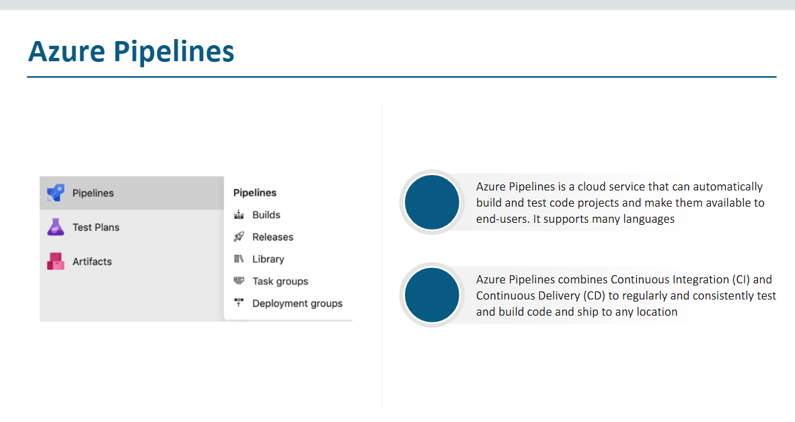  
  
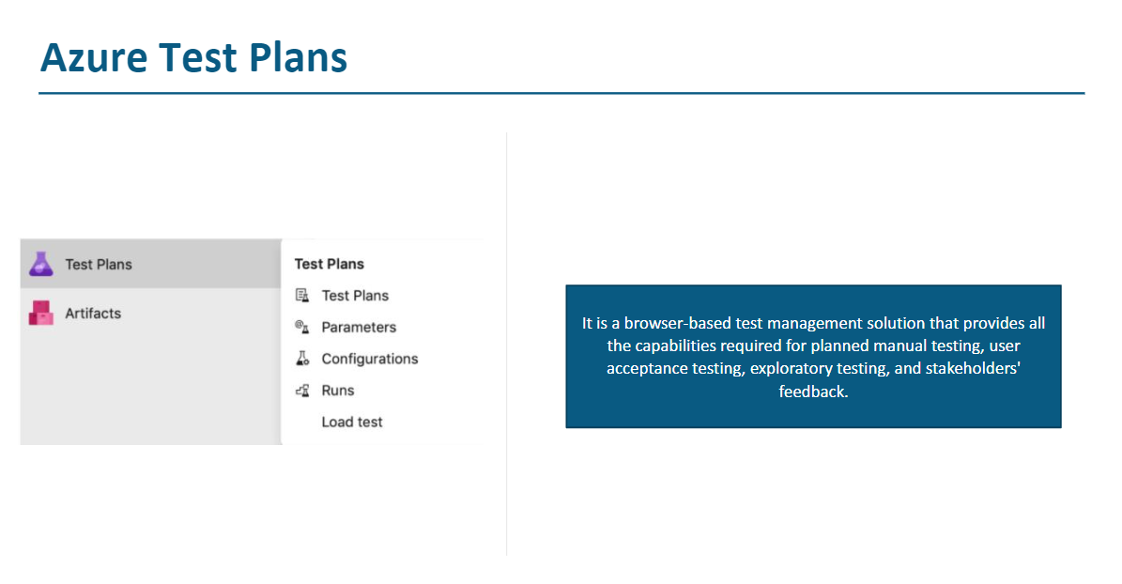  
**Artifacts** in **Azure DevOps** refer to **packages or files** generated during the build process and stored for later use, such as in **deployment** or **testing**.

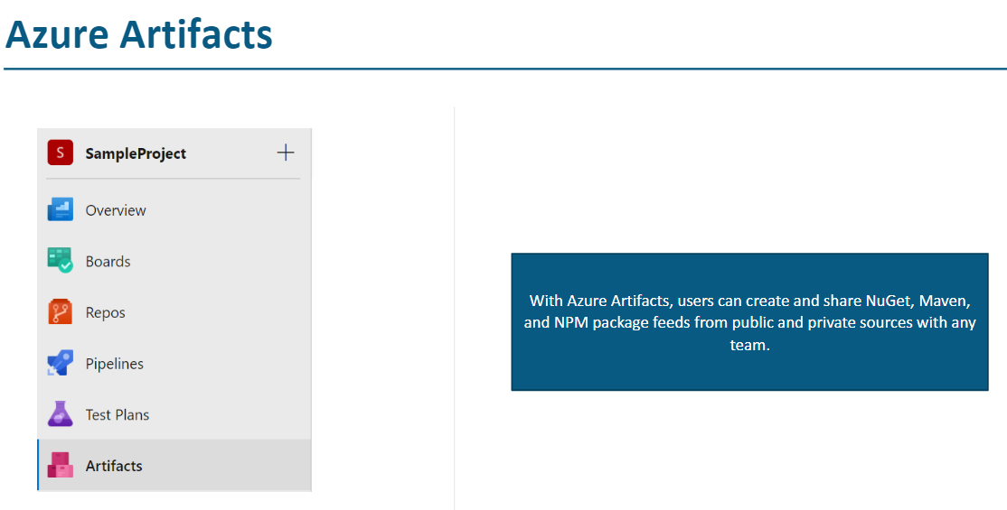

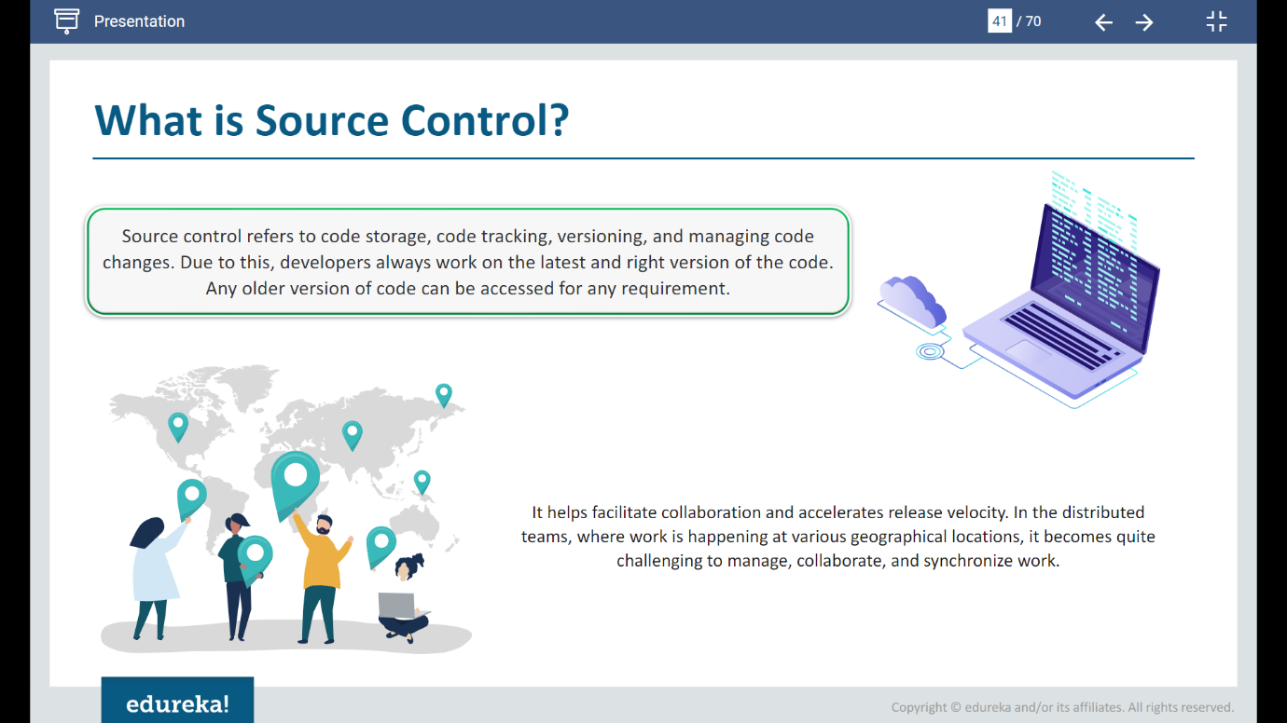**Git** : It’s a version control system where our code is stored ,vcs, where people can work on different branches from main branch and finally they can merge the code into main branch

• **Git is the tool** that performs the actual version control tasks on your local machine. No need of internet

• **GitHub is a platform** that hosts your Git repositories online and provides tools for collaboration and project management. Require internet and needs access to server  
  
🡪 We will have separate team to deal with development and testers to do testing , we will be mainly working on pipeline to automate the process ,

**Class2**:  
  
Azure projects are of 2 types

**\*\***What are the azure project and azure organizations  
  
**Azure organization**: Is a type of top level organization by means of which you can create multiple projects. We can keep and assign few configurations to all projects which are part of organization, it will be cascaded to underlying projects!  
  
**Azure project**: If you wanted to give permissions to specific users to specific jobs on your specific pipelines then you can give in project level  
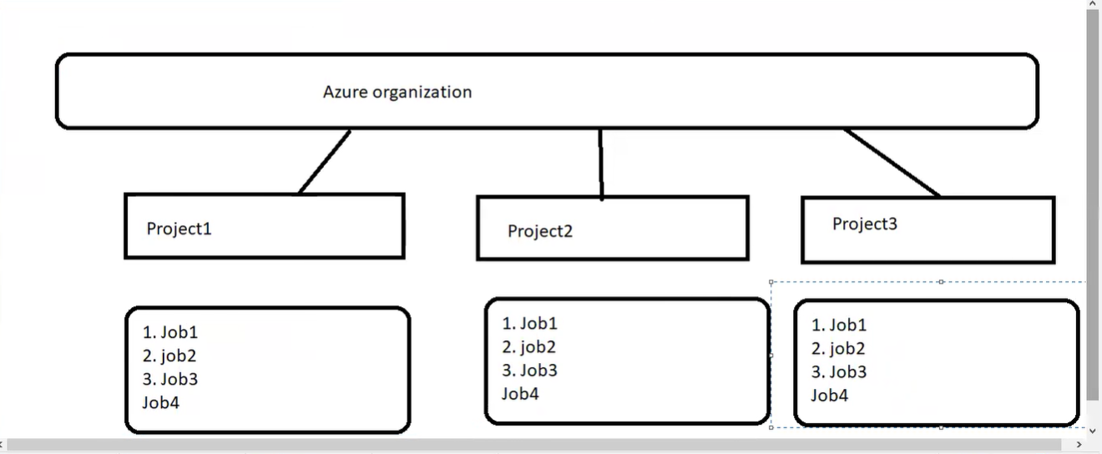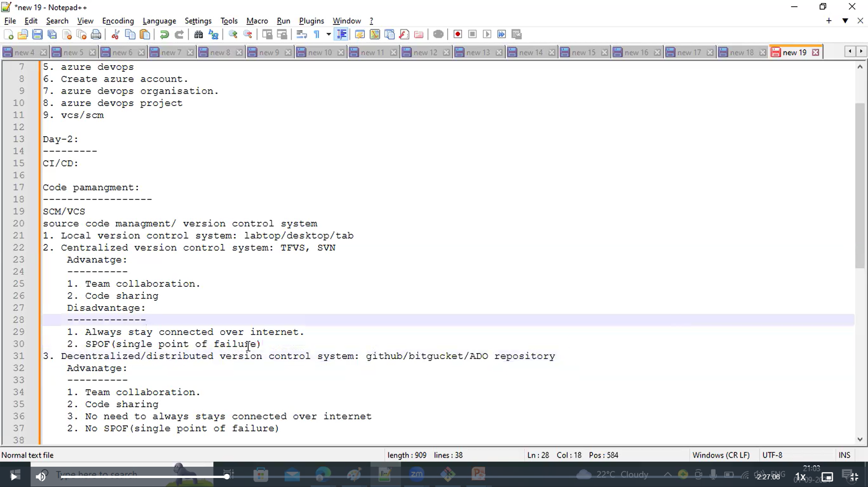  
  
Important linux commands:  
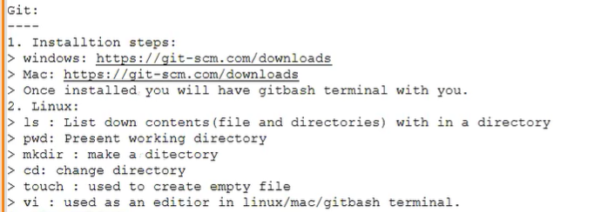  
  
🡪Being a azure devops engineer, you will be mainly working on repos and pipelines  
  
🡪Whenever you create new project, repo will be created by default  
 🡪 To represent URL We need to give a variable, when local repo is created by cloning it will be having a variable named **Origin** which holds value of URL  
Before pushing you need to make sure in which branch you need to push  
git push <repo url><in which branch you are pushing>  
  
**The Azure Account extension provides a single Azure sign in and subscription filtering experience for all other Azure extensions. It makes Azure's Cloud Shell service available in VS Code's integrated terminal.  
  
In this way we can integrate connection between azure repos and git  
Another way of doing this is by using **Visual studio** code  
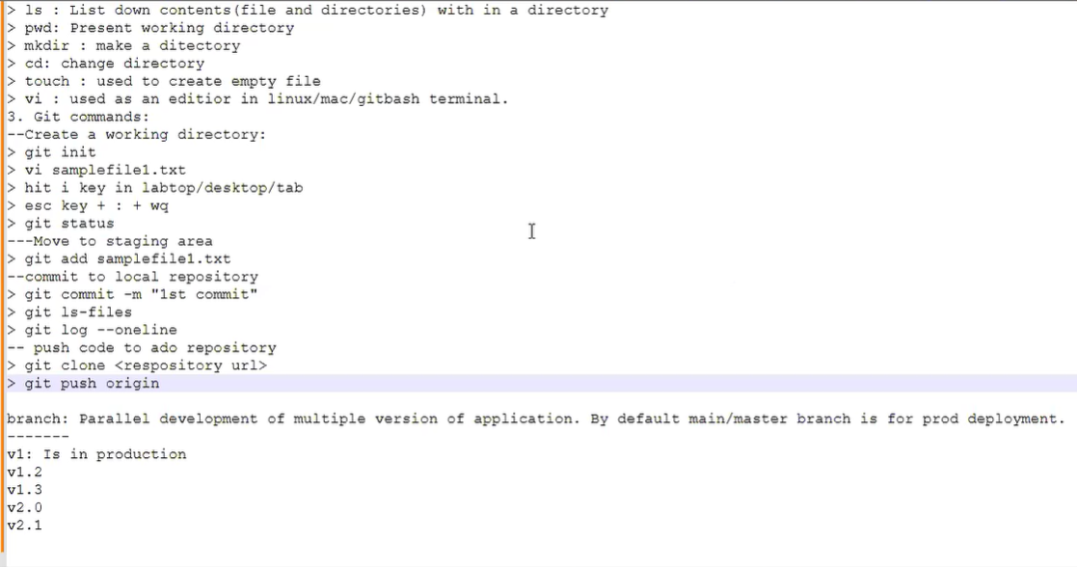  
🡪Usually you try to login to azure with credentials, Same way Vscode need to be integrated to azure , but it does not have the capability to directly connect with azure so it needs some kind of extensions  
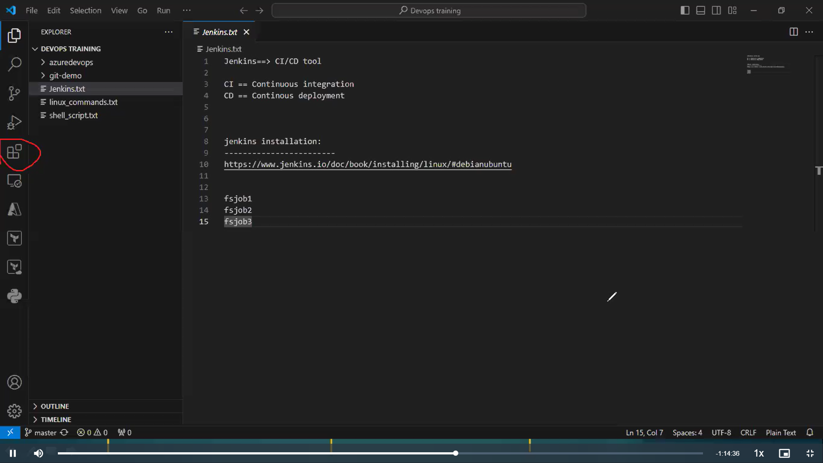  
  
Can be used for any kind of authentication or downloading extensions  
🡪You need to download azure account and azure repos extensions in VScode to proceed work!  
🡪 You don’t have any need to use any commands, when you give the repo and project it will be pulling all the files into VS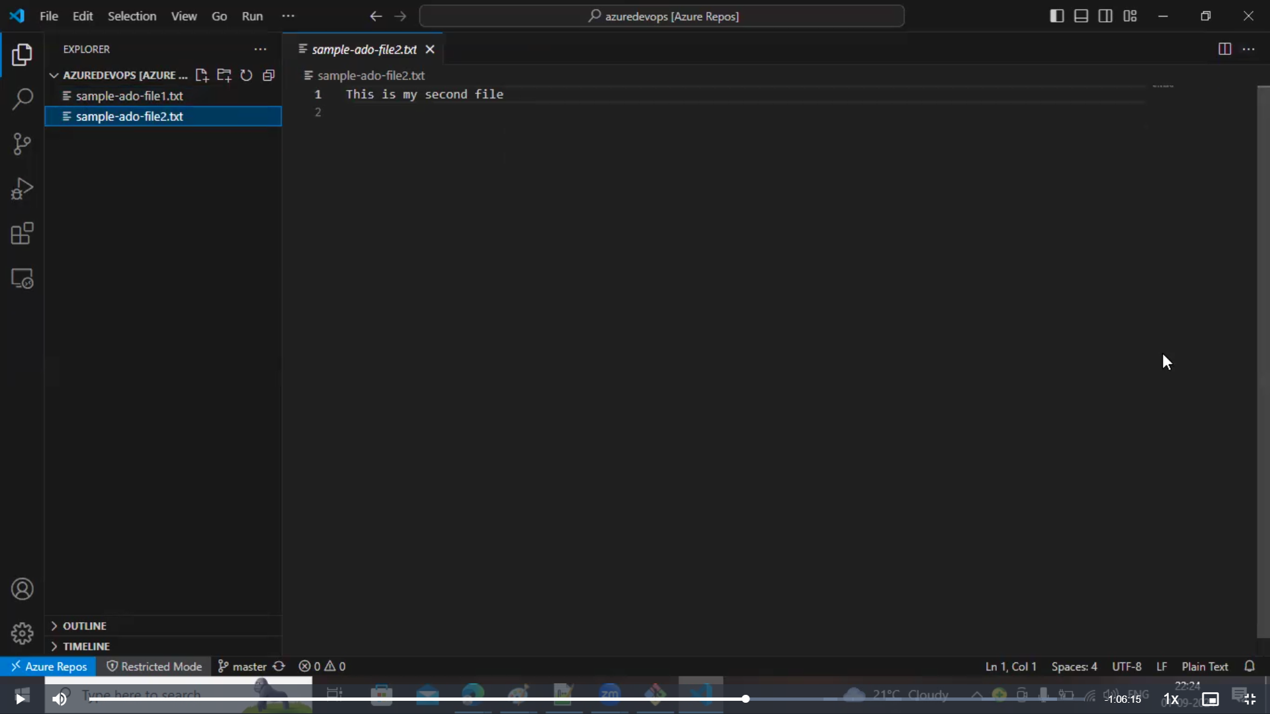  
🡪To detect the repos in VScode there should be atleast 1 file in that particular repo!  
  
 -> You cant have any repos without main/master branch, it is important to have main/master branch in most of repos!  
  
->if somebody asks you to modify something in main/master branch which is present in production, then you cant modify code directly in production master, so branches needed!  
  
🡪I have created another branch where I have made all the changes which are required to add in the application features than now I need to follow few steps to make the code go into production!  
  
🡪I need to raise a pull request , this can be viewed by clients,stakeholders,managers and they will analyse how the customers are going to get benefit out of it ,how they generate revenue from it  
  
🡪Merge happens from feature branch to master branch by 1 component which we call as **pull request**!  
  
🡪Any work item will closes once the pull request is approved, i.e., you have attached 1 work item and that request is approved, then you cant see same item in another pull req!   
  
**Config setup:**1. We have cloned the local repo from azure respos  
2. We can see that git is not installed automatically in VScode, so in system you need to have Git installed!  
3. Later you need to give connection between system git and vscode  
4. You can provide that linkage in git bash by running below commands  
  
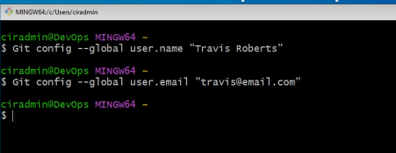  
.If still git is not recognized, then add user/userbin in environment variables  
  
**steps to remember before pushing or pulling from or into remote:**We need to make sure that local repo have all the files or commits before pushing into remote repo!

**Pipeline**:  
  
Every pipeline have yaml files in them  
  
2 ways to create this  
1.classic 2.yaml

🡪Classic is not in use so it wont allow you(ADO) to create it

🡪Only YAML pipelines can be created  
 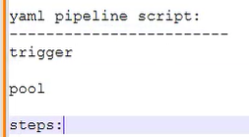  
🡪There are 2 ways to run pipeline -manually or by trigger  
There are few key words which are there in yaml pipeline file, let us understand those!

**Steps :** Any of your pipeline code must have option called steps , without this you will not be able to make the pipeline know what actions need to be performs

**Trigger:** If any update happens on master or any branch which u provides under trigger ,then that triggers the pipeline

**Pool:** Its something machine or operating system or platform where your pipeline runs! Those machines can be called by the key word pool!  
  
🡪sometimes you wont be having any code , they might present in some others repos , at that time you need to configure that codes from repo to ADO , to make pipelines run automatically or manually!  
  
🡪sample pipeline code links

  
  
**Creation of sample pipeline:**  
1. Connect: Click on create a pipeline, it will ask from which repos , i.e., either azure repos or github or bitbucket  
  
2.It will redirect to requested repo and you can see your repos then it will ask for approve or reject repo  
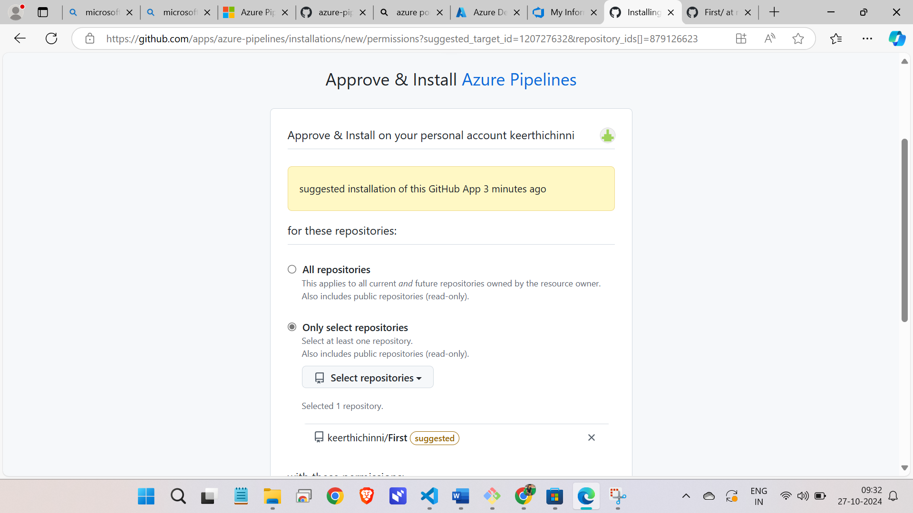  
  
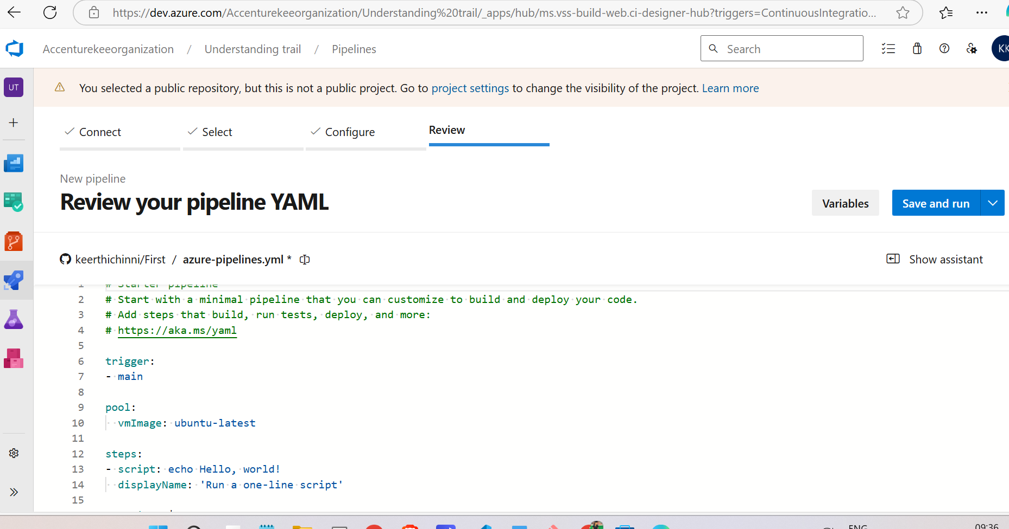

An **agent pool** in Azure DevOps is a collection of build or deployment agents that can be used to run jobs for your pipelines.

A **self-hosted build agent** in Azure DevOps is a machine that you set up and manage yourself to run build and deployment jobs.  
  
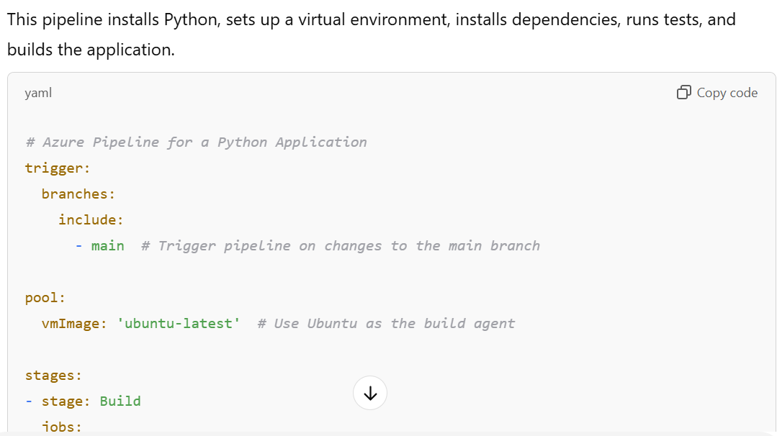  
  
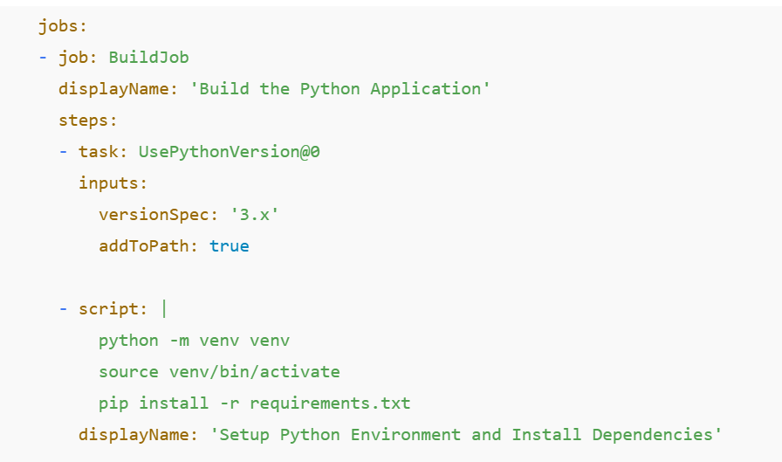

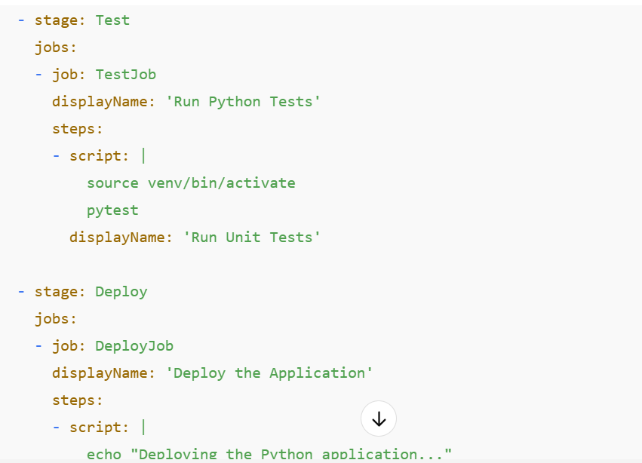  
  
Class:3-containerization

We have seen about micro services, different stages, before we used to deploy on physical servers, but later we changed to VMs and then to containers

Ecommerce giant-third party company  
If you are seller, another one is buyer, then there should be some third platform via which they can connect!

🡪During sale, there will be a lot of traffic in website

🡪First of all you need some space where your app will be displayed where your app will be storing the info of your cards via which you can do payment!  
  
🡪Being independent and linking are 2 different things

If 1 function should be definitely up and running to run another function then it is being dependent

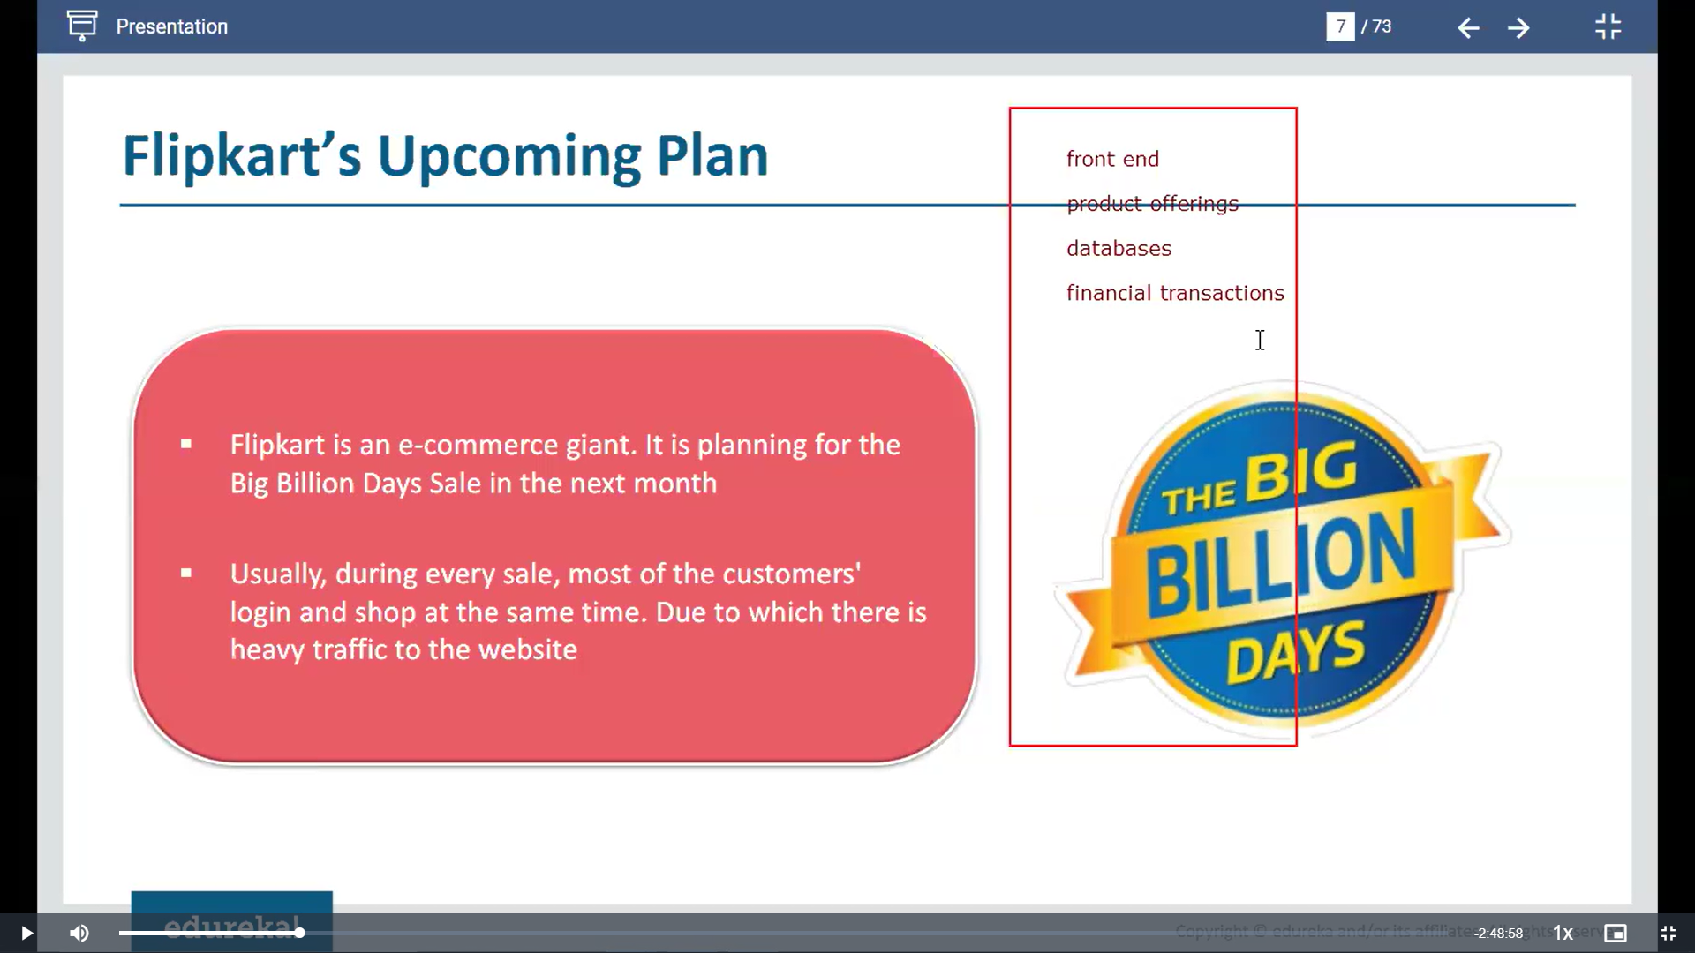  
  
Monolithic model:



🡪In old days, flipkart used to follow monolithic system where entire services are present in single system , when people uses it more, then data crashed and it effected another functions or components like front end,financial transactions and other stuff due to monolithic way asd they are present in single machine

🡪So here 1 component got issue and it indirectly effects other component from using as well

🡪There is no automation as well whenever we want to implement we cant do ,needs manual intervention

🡪There is no scaling feature as well, you cant increase database servers instantly and cant decrease whenever required so

To avoid this cons, we have VM model:

We have shifted from mono to Vm

Deployment of app using VM and microservices

**Microservices**: It breaks all app development and deployment work into pieces (micro services) and each service will be present in different services.

If 1 service breaks , other services will be still available

🡪This can be achieved by segregating all these apps in different VMs in different infrastructure setup!

1st VM -named “solarisis “ implemented by oracle

🡪Pros of shifting to Vm and Microservices is   
we can have autoscaling ,pay as you go model and automation also can be done using Iaac using pipelines  
  
🡪Docker is a containerization tool, whereas k8s is a orchestration tool!

Docker creates containers whereas you need k8s to manage those containers

Ex: flipkart receives many users on sale, so scaling should be up and more services needed to maintain, docker alone cant do it whereas Kubernetes helps to scale up or down

🡪It means having everything deployed in same machine, even if you create containers if all containers are in same machine, then spof occurs then it will be wasted

🡪What if we create containers and distribute it along different machines, then spof don’t occur at a time

🡪Azure Kubernetes services(AKS)-offered by azure cloud